Trading Blocs and Free Trade

LVL1 Answer the following questions as you read

1) What do trading blocs try to achieve?
2) What are some of the major trading blocs around the world?
3) Describe the makeup of the EU
4) Describe the makeup of NAFTA
5) Describe the makeup of ASEAN
6) What is free trade?

- Describe the purpose of trading blocs such as the EU, NAFTA, and ASEAN.

Trading blocs refer to free trade agreements among countries in a region. The goals for trading blocs may include reducing or eliminating trade barriers, increasing specialization and efficiency in production, allowing free movements of workers within the bloc, establishing a common currency, and/or coordinating infrastructure projects to facilitate efficient trade among members. Three examples of trading blocs are the EU, NAFTA, and ASEAN. As of May 1, 2017, the European Union (EU) had 28 member countries. Of the 28, 19 use the common currency the Euro and 26 enjoy the border-free movement of goods and people from country to country. Currently, the United Kingdom intends to leave the European Union within about two years. The North American Free Trade Agreement (NAFTA) is an agreement among the United States, Canada, and Mexico. This agreement allows for the free trade of many goods among the countries, encourages efficiency and specialization in production, and involves coordination among countries. NAFTA countries do not share a common currency or border free movement of goods and people. The Association of Southeast Asian Nations (ASEAN) is a trade bloc of 10 Southeast Asian countries. Like the NAFTA countries, the ASEAN countries promote free trade, specialization, and coordination among members, but do not have a common currency or border-free travel.
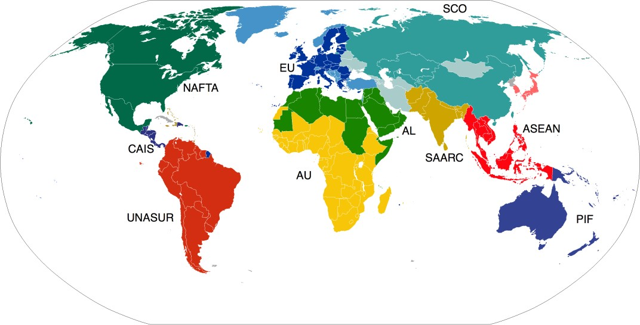
https://upload.wikimedia.org/wikipedia/commons/4/43/ActiveBlocs.PNG

- Evaluate arguments for and against free trade.
The main arguments against free trade include:
- Protecting infant industries – markets in need of time to develop before competing against foreign rivals
- Protecting national security
- Protecting domestic employment
- Protecting workers in developing countries from unfair labor practices
- Protecting the environment in developing countries
The infant industries argument supports the use of trade barriers when a new industry is in the early stages of development. Unless the industry can grow and establish economies of scale (high output with low cost per unit), it will be unlikely to survive in competition with established industries in other countries. Opponents of this argument cite the difficulty in accurately predicting which industries are likely to “grow up” and be competitive as well as the potential for retaliation by other countries.
The national security argument cites the importance of maintaining industries critical to the country’s national security even when the industry cannot efficiently compete at the international level. National security is also the argument behind an embargo. Opponents to this argument cite the potential for abuse because at some level many industries can argue their importance to national security.
The domestic employment argument seeks to protect workers of a country from becoming unemployed due to competition from products made by workers in developing countries who usually work for much lower wages and benefits. Opponents of this argument emphasize the increased consumer prices caused by the protectionism. Free trade and efficient production usually lead to new industries and jobs within those new industries. Finally, if workers in developing countries produce goods for which they have a comparative advantage, these workers will become richer and will become consumers of international goods as well as producers.
The protecting workers in developing countries from unfair labor practices argument is the basis for limiting the purchase of those goods by people in the developed country. By developed world standards, working conditions in developing nations are often very bad relatively speaking. However, opponents of this argument emphasize that workers in developing countries would lack jobs entirely if their countries were unable to produce and sell goods abroad. In the long-run, as industries in developing countries become more established and worker’s wealth increases, the workers will demand better working conditions.
The protection of the environment argument supports restrictions on trade with countries that have lax environmental standards. Opponents argue that developing nations must have the ability to produce goods without the same environmental standards as developed nations because they would be uncompetitive otherwise. Economic research shows that as a country becomes richer, the people of the country demand higher environmental standards. If countries increase growth, some economists believe an cleaner environment will follow.

LVL 2 Consider the following questions

7) What is a major difference between the EU and ASEAN?
8) Which trade agreement has the greatest impact on the U.S. and why?

LVL 3 Do the following

9) Make a table of the reasons for and against free trade
Reasons | For | Against

