Topic 5: Monetary Policy
LVL 1: As you read, answer the following questions
1. What is the central bank of the United States?
2. Why was the central bank created by Congress?
4. What are the roles of the Federal Reserve System?
5. What has been used for money in the past societies?
6. What is the term for official money that is used by governments of countries?
7. When does money function effectively?
8. How does money have value?
9. What are the three functions of money?
10. How is money used as a medium of exchange?
11. When does money function as a store of value?
12. Why must money have a unit of account?
13. Is the Federal Reserve a public (government) institution or a private bank?
14. How many Federal Reserve banks are there across the country?
15. Whose interests are represented by the district banks?
16. How are the board of governors appointed?
17. What is the FOMC?
18. What is the role of the FOMC?
19. Who serves on the FOMC?
20. Who always serves on the FOMC?
21. What are the three goals that the Federal Reserve (Fed) tries to meet?
22. What are the four main tools that the Fed can use to meet their economic goals?
23. Describe the purpose of the reserve requirement.
24. Describe the purpose of the discount rate.
25. Describe the purpose of paying interest on bank reserves.
26. What is the FFR?
27. What impacts the FFR?
28. What happens when the Fed increases the reserve requirement?
29. What happens when the Fed decreases the reserve requirement?
30. What effect does increasing the interest rate on reserves have on GDP?
31. What effect does decreasing the interest rate on reserves have on unemployment?
32. What happens when the Fed raises the discount rate?
33. What happens when the Fed lowers the discount rate?
34. What happens when the Fed sells government securities (bonds) on the market?
35. What happens when the Fed buys government securities (bonds) on the market?
36. What does the government try to achieve with fiscal policies?
37. What is the goal of lowering taxes and increasing government spending? (Expansionary Fiscal Policy)
38. What is the goal of increasing taxes and lowering government spending? (Contractionary Fiscal Policy)

SSEMA2 Explain the role and functions of the Federal Reserve System.

The Federal Reserve System is the central bank for the United States. Congress created the Federal Reserve in 1913 to provide stability for the U.S. financial system after the country experienced a series of severe financial crises. The Federal Reserve’s role in the economy includes conducting monetary policy, maintaining the stability of the financial system, supervising and regulating financial institutions, fostering a safe and efficient payments system, and promoting consumer protection and community development. Study of the Federal Reserve in this course includes: explaining the role and function of money, describing the organization of the Federal Reserve System, defining monetary policy and its tools, and describing how the Federal Reserve uses monetary policy to promote its dual mandate of price stability and full employment.

- Explain the roles/functions of money as a medium of exchange, store of value, and unit of account/standard of value.

Throughout history, money has taken many forms. We have used items like shells, animal skins, and precious metals as money. Money is what money does. Any item that serves the three main functions of money efficiently is good money. In most economies today, we use a type of money called fiat money. Fiat money is the official money issued by the government of a country. In most cases today, a country’s money works because of trust in the good faith and credit of the country’s government. As long as people are willing to accept a country’s money as a method of payment, the money functions effectively. Maintaining confidence in the U.S. monetary system is an important role of the Federal Reserve. For money to have value, people must believe it has value and it must serve the following three functions: medium of exchange, store of value, and unit of account (standard of value). Money used as a medium of exchange facilitates transactions between individuals, businesses, financial institutions, and governments in an economy. When a household wants to purchase groceries, it will use money to facilitate the transaction. The household could use cash, write a check, or swipe a debit card linked to a checking account. All of these methods of payment involve using money as a medium of exchange. The money payment people earn is income. Many people today receive this money payment through direct deposit into a checking account. After receiving their money payment, most people will designate some of the money for spending and some of the money for saving. When people hold money as savings for purchases sometime in the future, money functions as a store of value. People avoid holding savings if they fear a loss of purchasing power in the future. The belief that money saved today will purchase a similar amount of goods and services in the future is the function store of value. Money also functions as a guide. In the United States, the dollar is our unit of currency. When we look at our bank account balance or shop for goods and services, we see an amount expressed in dollars. This allows us to compare prices and determine whether we have enough in our account to make a particular purchase. This function of money is unit of account (or standard of value).

- Describe the organization of the Federal Reserve System (12 Districts, Federal Open Market Committee (FOMC), and Board of Governors).

The Federal Reserve System is unique among the world’s central banks for its decentralized structure and its public/private nature. In the Federal Reserve Act of 1913, Congress called for a decentralized structure with a maximum of 12 district banks located throughout the country. The district banks are the private part of the system and the Board of Governors is the public part. District banks operate under the direction of a private board representing banking, business and community organizations throughout the district. A selection committee of non-banker board members select the president of the district banks. The president and his or her professional staff are employees of the district and run the day-to-day operations of the district banks. The President of the United States nominates members of the Board of Governors and the U.S. Senate confirms them. They are the public part of the system. The Federal Open Market Committee (FOMC) is the monetary policy making body of the Federal Reserve System. When fully staffed, the FOMC includes the seven members of the Board of Governors and the 12 district bank presidents. Only five of the twelve district bank presidents are voting members of the FOMC at any one time. The New York District president always votes. The other four voting spots rotate among the remaining eleven district presidents. The image below shows the geographic location of the districts and Board of Governors.
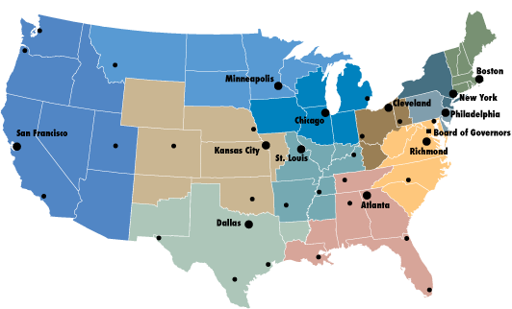
https://www.federalreserveeducation.org/about-the-fed/structure-and-functions/districts
The following image shows the composition of the Federal Open Market Committee.

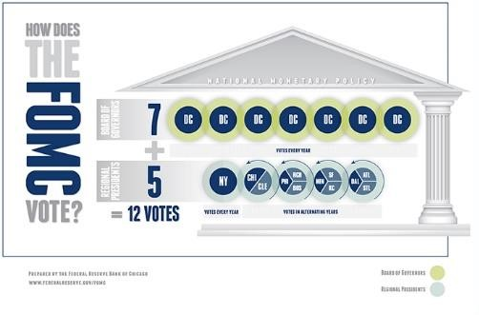
https://www.chicagofed.org/education/fomc-infographic

- Define monetary policy

According to the Federal Reserve’s 2016 edition of Purposes and Functions, “monetary policy is the Federal Reserve’s actions, as a central bank, to achieve three goals specified by Congress: maximum employment, stable prices, and moderate long-term interest rates in the United States.”

- Define the tools of monetary policy including reserve requirement, discount rate, open market operations, and interest on reserves.
According to the Federal Reserve Board of Governors, there are currently seven tools of monetary policy available to the Federal Open Market Committee. For the purposes of this course in economics, students must define four of these tools.
Reserve Requirement: The Federal Reserve requires most financial institutions to keep a percentage of customer deposits in vault cash or as a deposit in their account with the Federal Reserve. Banks cannot lend these reserves. In theory, if the Federal Reserve raised or lowered the reserve requirement, it would change the supply of money in the economy. However, the Federal Reserve rarely uses this tool.
Interest on Required and Excess Reserves: On October 1, 2008, Congress authorized the Federal Reserve to begin paying interest on the required and excess reserves of financial institutions. Prior to this change, financial institutions gained no return on their required reserves, acting as an implicit tax. Now, they earn a return on required reserves as well as any excess reserves they want to hold with the Federal Reserve. Financial institutions weigh the choice between earning interest on excess reserves from the Fed with the option to earn interest by loaning excess reserves to customers. If the Federal Reserve changes the interest rate on excess reserves, it changes the incentive financial institutions have to keep their reserves with the Fed, increasing or decreasing the money supply.
Discount Rate: One role the Federal Reserve plays in the economy is the “lender of last resort.” If financial institutions cannot borrow from each other, they may need to borrow from the Federal Reserve. The interest rate charged by the Fed, when lending to a financial institution, is the Discount Rate. When the Fed raises or lowers the discount rate, it is sending a signal to financial institutions telling them to increase or decrease their lending activity, affecting the money supply.
Open Market Operations: At each Federal Open Market Committee meeting, members vote to raise, lower, or maintain their target for an interest rate called the Federal Funds Rate (FFR). The FFR is the rate financial institutions charge each in the overnight lending market. The Fed targets the rate by buying or selling government bonds through primary dealers in the open market. As the FFR rises or falls, the incentives for financial institutions to borrow from each other changes, affecting the money supply.

- Describe how the Federal Reserve uses the tools of monetary policy to promote its dual mandate of price stability and full employment, and how those affect economic growth.

The Federal Reserve uses monetary policy to achieve its congressionally mandated goals of price stability and full employment. The following chart shows how each of the four policy tools discussed in SSEMA2d are used to achieve these economic goals and how economic growth is likely to be affected.

Tool | Action | When is the Fed most likely to use it? | Effect the Money Supply | Effect on Price  Level, Real GDP, & Unemployment
Reserve  Requirement | Increase the reserve requirement | When concerned about inflation  (Price Stability) | Money supply would decrease | Price Level falls  Real GDP falls  Unemployment  rises
 | Decrease the reserve requirement | When concerned about contraction or recession  (Full Employment) | Money supply would increase | Price Level rises  Real GDP rises  Unemployment decreases
Interest on  Required & Excess  Reserves | Increase the interest rate on reserves | When concerned about inflation  (Price Stability) | Money supply would decrease | Price Level falls  Real GDP falls  Unemployment  rises
 | Decrease the interest rate on reserves | When concerned about contraction or recession  (Full Employment) | Money supply would increase | Price Level rises  Real GDP rises  Unemployment decreases
Discount Rate | Increase the discount rate | When concerned about inflation  (Price Stability) | Money supply would decrease | Price Level falls  Real GDP falls  Unemployment  rises
 | Decrease the discount rate | When concerned about contraction or recession  (Full Employment) | Money supply would increase | Price Level rises  Real GDP rises  Unemployment decreases
Open Market Operations | Sell government securities on the open market | When concerned about inflation  (Price Stability) | Money supply would decrease | Price Level falls  Real GDP falls  Unemployment  rises
 | Buy government securities on the open market | When concerned about contraction or recession  (Full Employment) | Money supply would increase | Price Level rises  Real GDP rises  Unemployment decreases

LVL II Consider the following questions
- What steps would the Federal Reserve take to increase the money supply?
- What steps would the Federal Reserve take to decrease inflation?
- What steps would the Federal Reserve take to decrease the unemployment rate?

