Topic 4 Equilibrium

LVL I: As your read answer the questions that follow
- What is the market clearing price?
- Why do prices work its way toward equilibrium?
- What element goes on the x-axis?
- What element goes on the y-axis?

- Describe the role of buyers and sellers in determining market clearing price (i.e. equilibrium).

The market clearing or equilibrium price is the point of intersection between the market demand curve and market supply curve. This is also the point at which the quantity demanded by consumers is equal to the quantity supplied by producers. Buyers help determine this price by buying a smaller quantity of a good when they view the price charged by sellers as too high. Sellers respond by lowering the price. When buyers perceive a price as lower than equilibrium price, they will buy all of the available items as quickly as possible. Sellers will notice they are having trouble keeping the item in stock or lack the capacity to provide as many services as consumers want. Sellers will raise the price of the product. Through these interactions between buyers and sellers, price will work its way toward equilibrium.

- Illustrate on a graph how supply and demand determine equilibrium price and quantity.

To illustrate how supply and demand determine equilibrium price and quantity, start with a market graph. Draw a horizontal x-axis line and label it “Quantity”. On the left end of your x-axis, draw a vertical line upward to create a y-axis and label it “Price”. Create the demand curve by drawing a downward sloping 45-degree line from the top of the y-axis diagonally toward the right side of the x-axis. Label this curve “Demand”. Create the supply curve by drawing an upward sloping 45-degree line from the bottom of the y-axis diagonally upward away from the origin of your graph. Label this curve “Supply”. Find the place at which the demand curve crosses the supply curve. Draw a dotted horizontal line from the point of intersection to the left until it hits the y-axis. Label this y-axis value as “Pe”. Return to the intersection of the supply and demand curve. Draw a dotted vertical line downward to the x-axis and label this x-axis value as “Qe”. “Pe” is the equilibrium price in the market. “Qe” is the equilibrium quantity in the market as well as the quantity at which the quantity demanded is equal to the quantity supplied. The graph below illustrates the equilibrium in the market.

Demand

Quantity

Price

Pe

Qe

Pe is the equilibrium price in the
market. Qe is the equilibrium quantity
in the market. At a price of Pe, the
quantity supplied in the market is
equal to the quantity demanded.

Supply

LVL II Application
- Plot the following demand and supply schedules and determine the equilibrium quantity and price

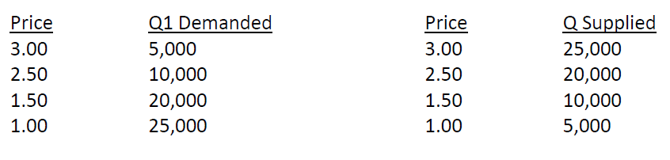

- Plot the following demand and supply schedules and determine the equilibrium quantity and price

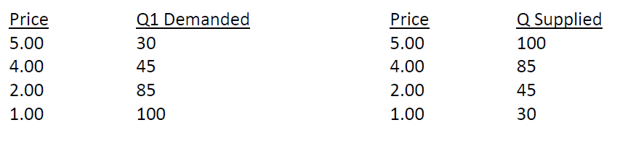

- Plot the following demand and supply schedules and determine the equilibrium quantity and price

