TOPIC 3 TAXES
LVL I: As you read, answer the questions that follow
- What are the three categories of taxes?
- In a Progressive tax, what happens to the tax when income increases?
- What is the rationale behind progressive taxes?
- What happens to the tax rate in a regressive system when income increases?
- Why are most sales taxes regressive?
- What is another name for a proportional tax?
- How much does everyone pay in a proportional tax system?
- What is a sales tax?
- What things does a sales not applied to?
- What is a property tax?
- What happens when property values rise?
- What is gentrification?

SSEPF3 Explain how changes in taxation can have an impact on an individual’s spending and saving choices.
Government assesses taxes on individuals and firms in an economy to pay for public goods and services. Some common taxes paid by individuals include income, property, and sales tax. When the government increases taxes, individuals will have less of their income to save and spend. When government decreases taxes, individuals will have more income to save and spend.
- Define progressive, regressive, and proportional taxes.
Taxes can fall into three categories: progressive, regressive, and proportional. The category into which a tax falls determines how it will affect people who make higher or lower incomes.
A Progressive tax rate increases as income increases, meaning the wealthy pay a higher percentage of their earnings than people less financially well-off. The U.S. federal income tax is a progressive tax. For example, a progressive tax might have a tax rate of 1% for every $10,000 earned annually, with a maximum tax rate of 50%. This system would lead to the following example.

Progressive Income Tax Example
Income |  | Tax Rate | Calculation | Total Tax
$10,000 | 1% |  | $10,000 X .01 | $100
$30,000 | 3% |  | $30,000 X .03 | $900
$200,000 | 20% |  | $200,000 X .20 | $40,000
$500,000 | 50% |  | $500,000 X .50 | $250,000
In the example, people earning $30,000, or three times as much as those earning $10,000, would have to pay nine times the amount in taxes ($900 compared to $100). Those earning $200,000, more than six times as much as those earning $30,000, would have to pay more than forty-four times as much in taxes. While this may seem excessive, the rationale is that a progressive tax takes more money from those who can afford to pay it. Opponents of progressive taxes argue that higher tax rates for high income earners is a disincentive to engage in productive activity.
A Regressive tax is a tax rate that decreases as income increases. Consider a tax that imposes a flat rate of $1,000 annually regardless of income. For someone earning only $3,000 a year, this tax would be huge, accounting for one-third of all earnings. To someone earning $50,000 a year, the tax rate is not as large, accounting for only 2% of annual income. Most sales taxes are regressive because lower income people tend to spend a greater proportion of their income on sales taxed items than higher income people.
A Proportional tax, also known as a flat tax, does not change with respect to changes in income. If the proportional tax rate is 15%, then everyone pays 15%, regardless of whether he or she makes $10,000 or $570,000. The FICA tax workers pay to fund Social Security and Medicare is proportional. Everyone pays the same percentage of their income to this tax up to a specified income cap.

- Explain how an increase in sales tax affects different income groups.

Sales tax refers to a consumption tax levied on people when they make certain kinds of purchases, such as buying a book or eating out at a restaurant. Not all goods and services are subject to a sales tax; doctor visits, for example, are free of taxes. Like the different types of income taxes, a change to the sales tax affects different income groups in different ways. Since all consumers purchase essential goods like food, a high sales tax on food would affect poor people more than wealthy people because both groups will be paying the same tax rate for the same good. For this reason, economists usually classify sales tax as a regressive tax because it takes a greater percentage of income from a low-income person than from a high-income person. This is one reason why food is often not subject to a sales tax.
However, food served at a restaurant typically is subject to a sales tax, since eating out is a luxury.

- Explain the impact of property taxes on individuals and communities.

Property tax refers to a tax on real estate people own. The tax, levied by local governments like counties or cities, is on the value of the real estate. Periodic appraisals of a property’s value indicate whether the tax on the property will rise or fall. Increases in property value are cause for celebration by those ready to sell their property. However, for those who wish to remain in their homes, increased property values translate to increases in property taxes. If property taxes increase drastically, lower income people may no longer be able to afford the taxes on their homes. Delinquent taxes accrue interest and fees increasing the total bill owed. Various entities can use the delinquent tax bill to start the foreclosure process even properties fully owned with no mortgage. For this reason, owners of previously low value properties can lose their homes as property values rise and they are unable to afford the tax bill. This is gentrification. Gentrification occurs when high-income property owners replace low-income property owners in an area. Since taxes assessed on the property’s value are without regard for the income of the owner, these taxes are regressive.

LVL II APPLICATION
Different tax structures result in different tax rates or percentages for levels of income. In the table below, there are seven different income levels listed in the AGI (Adjusted Gross Income) column. There are three different tax structures for each income level: Tax A, Tax B, and Tax C. The percentage of AGI that is due in taxes is provided for each tax structure. Complete the chart by calculating the tax due for each income level based for each tax structure.
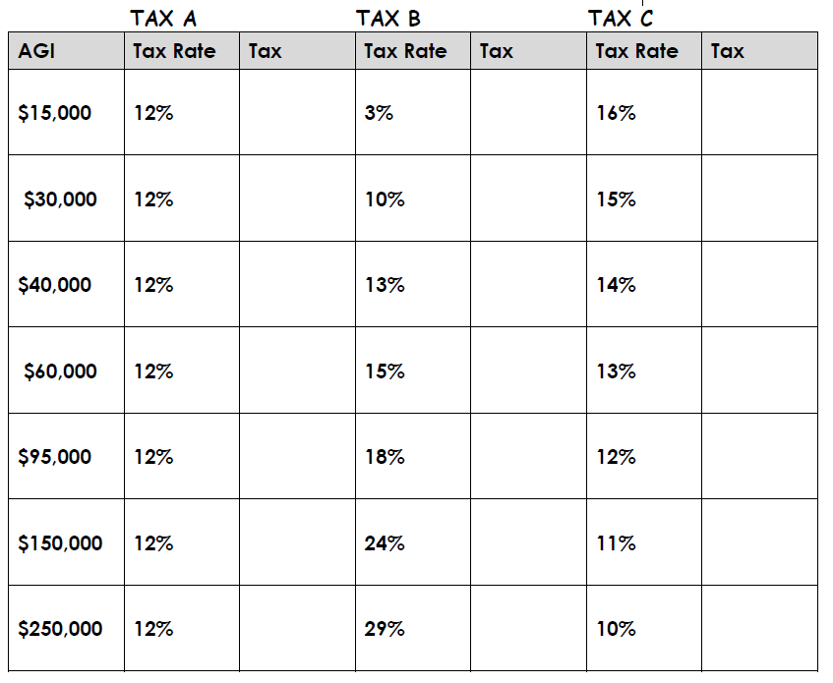

1. Which tax structure is an example of a proportional tax?
2. Which tax structure is an example of a regressive tax?
3. Which tax structure is an example of a progressive tax?
4. Which tax structure in the table comes closest to meeting the criteria for “the perfect tax structure?” On a separate sheet of paper, write an essay defending your choice. Include information on the effects of your choice on individual taxpayers, society, and the government.

