TOPIC 2 FINANCIAL INSTITUTIONS
LVL I: As you read, answer the questions that follow
- How are banks like other businesses?
- How do banks money?
- What are the four different types of financial institutions?
- Which of the types is the safest?
- Which provides the most choices?
- Which institution is owned and controlled by its members?
- Who charges the highest interest on loans?
- What is collateral?
- What happens when you fail to pay on your pay-day loan?
- What is interest charged?
- What is interest earned?
- What is risk?
- What is return?
- What is six different types of investments?
- How much risk do saving accounts have?
- How much return to saving accounts have?
- What determines how much return a CD has?
- What happens when you take your money out of a CD early?
- What is the most common type of retirement savings?
- What is the difference between a ROTH and traditional IRA?
- If you buy a Treasury Bond, who are you giving money to?
- What is the risk of Treasury Bonds?
- What are mutual funds?
- What makes them less risky than individual stocks?
- What types of stocks are less risky?
- What types of stocks are more risky?
- Why would you invest in a risky stock?

SSEPF2 Explain that banks and other financial institutions are businesses that channel funds from savers to investors.
Banks and other financial institutions are businesses. Like other businesses, banks must be profitable to operate. While banks collect revenue from a variety of activities, their traditional source of revenue comes from their role as a financial intermediary. This means taking the deposits from one group of customers and loaning a portion of deposits to other customers. Banks make revenue by charging borrowers a higher rate of interest than they are paying to depositors. This is called the “spread”.
a. Compare services offered by different financial institutions, including banks, credit unions, payday lenders, and title pawn lenders.
There are many types of financial institutions and they offer a variety of services. Potential customers must compare services to determine which option fits their needs. The financial institutions detailed in this course include banks, credit unions, payday lenders, and title pawn lenders.
Bank—For most consumers, banks provide a safe means to store earnings. Typically, banks also offer direct deposit (where a person’s paycheck goes directly into his or her account), check-writing services, debit and credit cards, loans of all sorts (personal, home equity, business), and a host of other services.
Credit Union—Credit unions provide services similar to a bank; the main difference is that a credit union only provides these services to its members. Members own and control the institution. Credit unions often offer higher interest rates on deposits and lower interest rates on loans than banks.
Payday Loan Company—Suppose you need $50 on Wednesday but won’t get paid by your job until Friday. To solve this temporary problem, a payday loan company will give out small loans in return for a portion of the upcoming paycheck. This means the person will get $50 on Wednesday, but come Friday, $55 of his or her paycheck will go to the payday loan company. Payday loan companies generally charge much higher interest on loans than other institutions.
Title Pawn Lender – Title pawn lenders provide short-term loans to individuals facing a gap between their income and expenses. Usually, those accessing loans through title pawn lenders lack access to other types of short-term loans like credit cards. Title pawn lenders make loans based on an individual’s collateral. Collateral is an item of value one owns like a car. Lenders can sell the collateral to cover the value of an outstanding loan if the borrower cannot repay. Like payday loans, the fees associated with title pawn loans are usually much higher than those a bank would charge. In the case of title pawn loans, the inability to repay the loan could result in the loss of the vehicle put up as collateral.

b. Explain reasons for the spread between interest charged and interest earned.

Commercial banks, and other financial institutions offering loans, are businesses. They must make a profit if they expect to continue operating. One primary way banks make profits is by taking the money deposited by bank customers and loaning out a portion to people who want to borrow. By charging interest on the loans, banks make money. The more money on deposit, the more loans they can make, which is why some banks offer very generous checking account services. The interest on the loans is always more than the interest paid out to depositors. If banks did not have this “spread” between interest earned and interest charged, they would go out of business very quickly.

c. Give examples of the direct relationship between risk and return.

The relationship between risk and return is that the higher the potential return offered by a savings or investment opportunity, the more risky the savings or investment usually is. Therefore, if someone offers a 20% return and no risk, the person is most likely not being very honest. The options below give an idea of the relationship between risk and return:

- Evaluate the risk and return of a variety of savings and investment options, including: savings accounts, certificates of deposit, retirement accounts, stocks, bonds, and mutual funds.

Savings Accounts - Savings accounts are bank accounts in which people put savings to which they need easy access. The Federal Deposit Insurance Corporation (FDIC) most types of bank deposits up to $250,000. There is virtually no risk that the depositor will lose his or her money. The only risk comes from inflation risk. This means that the interest earned on the savings is less than the rate of inflation. Therefore, money held in a very low interest savings account is likely to erode in value over time. Since savings accounts are very low risk, the rate of return is very low as well. Most bank pay less than 1% interest on savings.
Certificates of Deposit – Certificates of Deposit (CDs) are products offered by banks. Buying a CD means you will earn a higher rate of return than on a regular savings account. The higher rate of return results from the saver agreeing to keep the funds in the CD for a specified period, usually between 1 months to 10 years. The longer the period, the higher the interest rate. People who save in CDs and need to withdraw their funds early will pay a fee for early withdrawal.
Retirement Accounts – Saving for retirement is a key goal for many people in the United States. Very few employers offer traditional defined benefit pensions and most retirees will need to live off their savings to maintain their standard of living. There are a number of retirement account options for workers. The most common account is a 401K. This is provided through an employer which will sometimes offer a percentage of matching funds. Individuals can also establish their own Individual Retirement Accounts through an investment bank. They usually have a choice between a Roth IRA and a traditional IRA. Roth IRAs allow contributors to pay taxes today and withdraw the funds they contributed tax-free in the future. The contributor will still have to pay taxes on any “gaines” they withdraw from their account in retirement. A traditional IRA allows contributors to put money away before taxes are paid. The taxes are paid on the money when it is withdrawn during retirement. All of these retirement account options offer portfolios with mixed investment options. People can chose high risk, high return stock funds or low risk, low return bond funds. Finally, the U.S. government has a program called MyRA for workers whose employers do not have a 401K. It allows workers to contribute up to $15,000 before having to roll it over into an account with an investment bank. The funds can be withdrawn as needed without penalty and are guaranteed by the U.S. government, causing the return to be small.
U.S. Treasury Bonds – Purchasing a U.S. Treasury Bond means you have loaned the U.S. government money. The government pays you a guaranteed rate of return. Since the U.S. government repays its debts, the rate of return is low. For example, the interest rate on a 5-year treasury bond on April 27, 2017 was 1.822%. The interest rate on 10-year treasury bonds was 2.3%. Bonds are safe but also carry an inflation risk if interest paid is not higher than the inflation rate.
Stock Mutual Funds – While individual company stock is relatively risky, many people choose to play the stock market by purchasing mutual funds. Mutual funds provide more protection against loss because the investment is spread across many different companies rather than just one company. You may also select funds that reflect specific levels of risk or your values. Long term investing tends to give a greater return in the stock market than short-term investing. Over a 20-year period, the stock market returns on average 7-8%. However, when holding stocks for only 5 to 10 years, the average rate of return drops to 1- 2%.
Stock – Purchasing stock of individual companies is one of the more risky ways to invest. When purchasing stock in large stable companies (blue chip stocks), your investment could be safer, but your rate of return is likely to be lower. If you invest in companies with a shorter history or a brand new product, the potential return is generally high if the company succeeds, but you are much more likely to lose your investment because of the high rate of new business failures.

LVL II APPLICATION

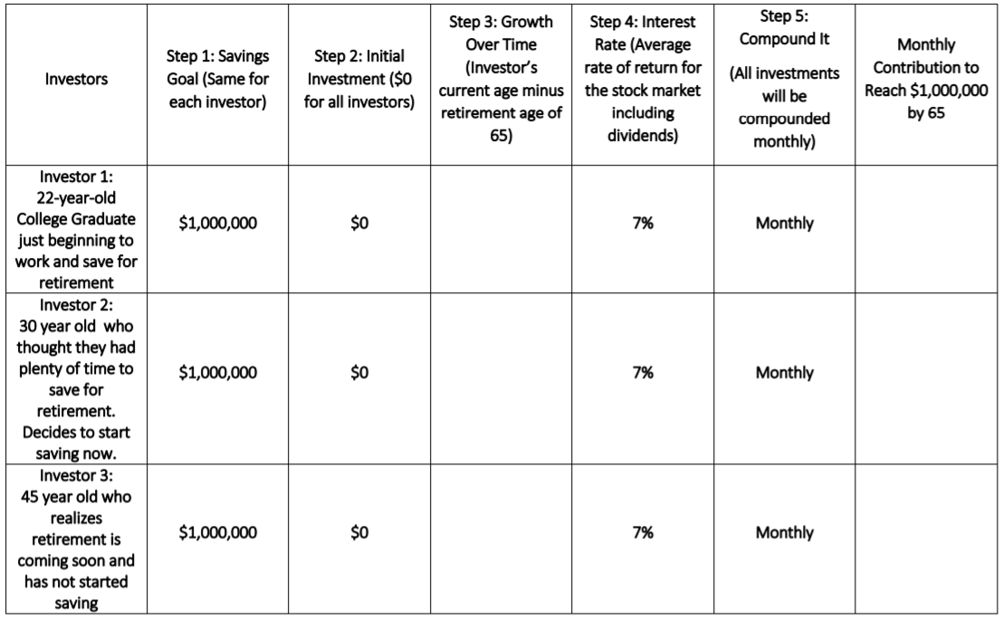
Debrief Questions
1. To reach the goal of $1 million, how much more will Investor 2 save per month than Investor1? What about Investor 3?
2. What might be an opportunity cost for early investment?
3. List some lifestyle changes Investor 1 could make to save for retirement (location housing, type car, etc.).
4. What are the incentives for early investment?
5. What is more important the amount invested or the amount of time? Explain

