Topic 2: Business Cycle
LVL 1: As you read, answer the following questions
- What does the business cycle illustrate?
- What do the X and Y axis represent on the business cycle?
- What are the 4 stages of the business cycle?

Economic activity derives from the sectors of the economy we explored in the fundamentals and microeconomics domains. Individuals, businesses, markets, and governments all interact to create a country’s economy. The degree of strength or weakness of all economic activity in an economy will affect the individual components of that economy. For this reason, public and private entities constantly measure specific types of economic activity and synthesize the data to create a picture of the economy’s health. The pictures drawn by the data inform policy makers who may choose to intervene in the economy to meet economic goals.

SSEMA1 Illustrate the means by which economic activity is measured.
- Define the stages of the business cycle, including: peak, contraction, trough, recovery/expansion as well as recession and depression.
The business cycle is an economic model illustrating how economic activity fluctuates over time. The y-axis in the model is Real GDP and the x-axis is Time. The x-axis values are usually months, quarters, or years. The business cycle graph looks a graph of waves from the field of Physics. The graph shows a period of rising Real GDP reaching a high point and then falling until reaching a low. After the lowest point, Real GDP recovers and begins to rise again. The whole cycle repeats itself. The graph below shows the business cycle model. The graph that follows the model shows real data about the U.S. economy.
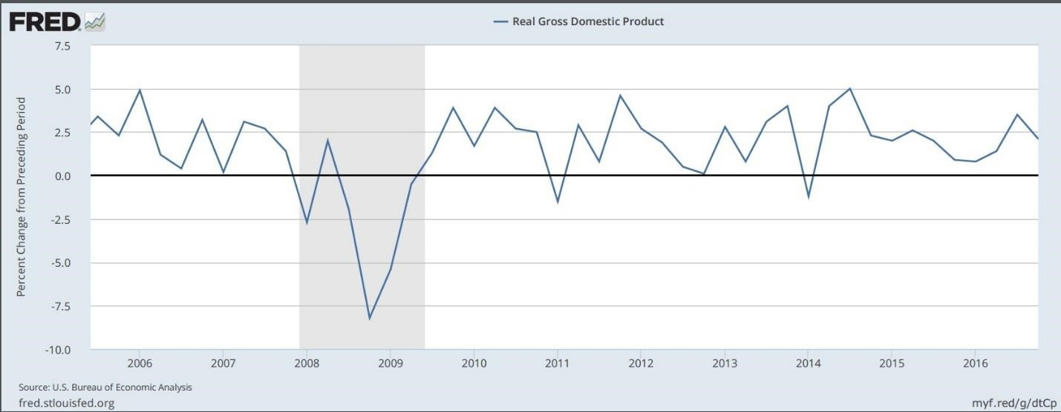

A
https://fred.stlouisfed.org/series/A191RL1Q225SBE

Time

Real GDP

Trough

Peak

LVL II Consider the following questions
- Define each of the four stages of the business cycle.
- Using the above graphic, at what stage of the business cycle is the US economy operating in 2008?
- Using the above graphic, at what stage of the business cycle was the US economy operating in 2014?
- Describe the performance of the US economy between 2006 and 2010?

