TOPIC 1 LIFE AFTER HIGH SCHOOL
LVL 1: As you read, answer the questions that follow
- What is the rational decision making model?
- Who determines the criteria for a post high school rational decision making model?
- What is a budget?
- What does a budget allow people to do?
- For most Americans, what determines the earnings of workers?
- What are soft-skills?
- What are the six soft skills?
- What are the three factors that determine a person’s wage?
- What rule helps to raise a person’s wage?

SSEPF1 Apply rational decision making to personal spending and saving choices.
A rational decision making model refers to a process individuals, firms, and governments use to evaluate the costs and benefits associated various options when making a choice. The model consists of the possible options evaluated against a set of desirable criteria identified by the decision maker who chooses the option most closely aligned to the criteria. Two life choices demanding a rational decision making model include major spending decisions and major saving decisions.
- Use a rational decision making model to evaluate the costs and benefits of post-high school life choices (i.e., college, technical school, military enlistment, workforce participation, or other option).
All high school students choose a post-high school path. Using a rational decision making model makes the costs and benefits of this choice easier to evaluate. For example, a hypothetical student chose his or her own criteria and assigned a score based on his or her own research. The student also should chose the weights for the criteria according to his or her own values and priorities. The results will vary greatly from student to student.
b. Create a budget that includes a savings or financial investment plan for a future goal.
A budget is a document listing all the income a person makes each monthly and the expenses a person must pay each month. A budget allows people to make a plan for the money they earn, keep track of their spending, and plan for future expenses.
SSEPF6 Describe how the earnings of workers are determined in the marketplace.
In the United States, supply and demand determine the earnings of workers. The exception is minimum wage laws at the federal, state, and local level. Minimum wage is a price floor. If equilibrium wage falls below the price floor, employers are bound to paying the legal wage. In most cases, minimum wage affects only markets for the least skilled workers. The labor market is a resource market. Employers demand workers and workers supply their labor. The intersection of the labor demand and supply curves indicated the equilibrium wage in the market. Like a product market, changes in the economy shift the supply of and demand for labor altering the equilibrium wage.
- Identify skills that are required to be successful in the workplace, including positive work ethic, punctuality, time management, teamwork, communication skills, and good character.
Successful workers practice key behaviors known as soft skills. Soft skills every worker needs include: work ethic, punctuality, time management, teamwork, communication skills, and good character.
Work ethic refers to how seriously one pursues the expectations associated employment. People with good work ethic practice all the soft skills listed above. When at work, people with good work ethic spend their time pursuing the goals of the job and producing excellent results to the best of their ability. Examples of poor work ethic include spending work hours pursuing personal interests, finding ways to avoid work, letting coworkers perform one’s assigned job functions, doing the minimum amount of work required to get by, and/or not following the rules outlined by the employer.
Actor Woody Allen once said, “Ninety percent of success is just showing up.” Punctuality means arriving on time and ready to work at the established time. Many employers of young workers lament how many lose their jobs due to lack of punctuality.
Most workers divide their work time among many different tasks and responsibilities. Workers with good time management skills efficiently organize their work hours to accomplish all objectives with minimal stress.
Today’s workplace is increasingly flat. This means rather than many layers of managers, many people work on teams lead by peers or lead teams of peers. These teams are often cross-functional meaning they are composed of people with different skill sets. Teamwork is part of most jobs. Team members need to work well with each other, support each other, and perform their assigned tasks well.
Excellent verbal and written communication skills help workers perform their jobs well. This means knowing how to get your ideas across to someone else and using appropriate style, grammar, and/or spelling. These skills help everyone understand what is expected and keep people motivated. Poor verbal and written communications skills cause workers to be viewed negatively and can cause conflict. In dangerous or high-risk environments, poor communication skills could put lives at risk.
Good character refers to doing the right thing every time. Today’s workers often enjoy a lot of freedom in how and where they work. Working remotely requires discipline to stay on task and meet goals. Employers need workers who behave ethically. Poor character traits include stealing from an employer, lying, plagiarizing the work of others, and treating coworkers or customers poorly.

- Explore job and career options and explain the significance of investment in education, training, and skill development as it relates to future earnings.
Since societies are constantly changing, and their economies— and marketplace demands— change as well. At some point in the 20th century, people who excelled at selling typewriters could probably have demanded a high salary for their work. Today, this expertise is no longer in demand, so work would be hard to get and at a much lower wage than it once was.
In general, the three factors determine the wage a worker can expect. The strength of demand for workers in the market, the number of workers supplying their labor in the market, and the amount of specialized knowledge, skills, training, and licenses are required to do the job.
As a rule, the more knowledge, skills, education, and training a worker has, the higher the wage the worker can expect assuming their education applies to a field with strong employer demand.

LVL II APPLICATION
Use the following information and the rational decision making model to determine which school would be best for Jerry, a Senior in the Cobb County School system to attend.
Jerry is a senior in Cobb County. He parents both work and have decent jobs but they don’t have a lot of money for Jerry to go to school. He wants to have fun at school, since he is having lots of fun in high school. Because of this his current GPA isn’t the best at a 2.7. Jerry would like to stay close to home and very much wants to study Farming.

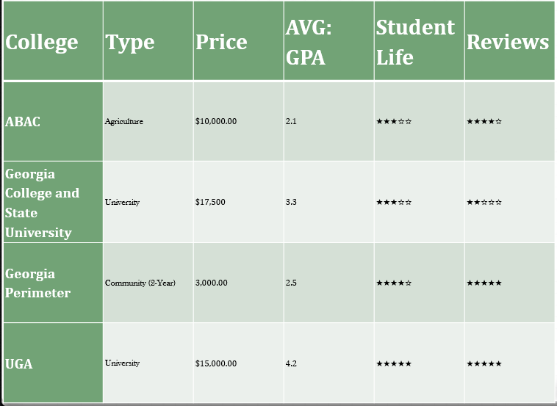

Level III

Based on the concepts above, create your own rational decision-making model chart of YOUR OWN post-secondary choices. Based on the categories, what option did you choose? Why does that option make the most sense for you?

