Absolute vs Comparative Advantage
LVL1 Answer the following questions as you read

1) What is trade?
2) What is international trade?
3) Why do people or countries trade?
4) Is trade always beneficial?
5) Define absolute advantage.
6) How do countries have an absolute advantage over other countries?
7) Define comparative advantage
8) Define balance of trade
9) When does a country have a trade surplus?
10) When does a country have a trade deficit?
11) Why might a large trade deficit hurt a nation's economy?

- Define and distinguish between absolute advantage and comparative advantage.
Trade refers to the exchange of goods, services, and/or productive resources among individuals, businesses, and/or governments. Trade refers to exchange among people within a country as well as international trade among people from many countries. Economic models suggest domestic and international trade improve a country’s economy. However, some individuals, firms, and/or industries experience difficulties as trading relationships evolve over time. As with all choices, costs and benefits exist.
Absolute advantage refers to an individual, firm, or country using the fewest inputs to produce the same amount of output or the individual, firm, or country producing the largest number of units of output given the same productive resources.
For example, imagine two countries, Jasminia and Lauraland, both producing MP3 players and Tablet Computers. In the example below, the problem presented is an INPUT problem because the numbers represent the labor hours used to produce one unit of each good. Since Jasminia only takes 10 hours to produce a unit of MP3 players while Lauraland takes 15 hours, Jasminia has the absolute advantage. In the case of the tablet computer, both countries take the same number of hours so neither has the absolute advantage.
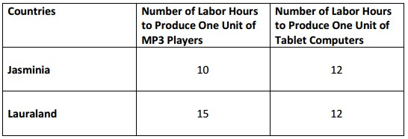
Now, imagine that Matthewtopia and Damianland are both producing MP3 players and Tablet Computers. However, the problem presented below is an OUTPUT problem because the numbers represent the number of units of each good they can produce given a fixed resource, in this case one hour of time. Since Damianland produces 9 MP3 players while Matthewtopia produces only 4 MP3 players, Damianland has the absolute advantage. In fact, Damianland has the absolute advantage in both good because it produces more of both per hour.
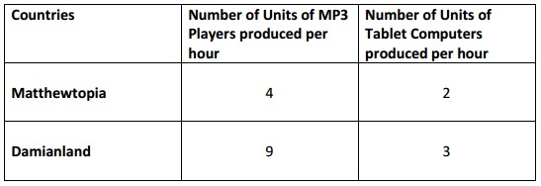
While large, more technologically advanced countries will probably have an absolute advantage in production over smaller countries, both countries can still benefit each other through specialization and trade.
The economic model explaining the how two entities can benefit from trade is the law of comparative advantage. Comparative advantage in production of a good or service exists when one individual, firm, or country has the lowest opportunity cost for producing the good or service.
To illustrate comparative advantage, let us look again at the example using Jasminia and Lauraland. Remember, this is an INPUT problem because the numbers represent the labor hours used to produce one unit of each good. Use the labor hours to find out how many units of tablet computers each country must give up to produce MP3 players. For input problems, we have to express opportunity cost as the ratio of “what we are producing” divided by “what we are giving up”. The ratios in each box below represent the opportunity cost of producing each good.
When reading this information, say it the following way:
“When Jasminia produces MP3 players, it gives up .833 of a tablet computer. When Lauraland produces MP3 players, it gives up 1.67 tablet computers.”
Since Jasminia gives up less to produce MP3 players, it has the comparative advantage in production. It should specialize in this product.
“When Jasminia produces Tablet Computer, it gives up 1.2 MP3 players. When Lauraland produces Tablet Computer, it gives up .6 of an MP3 player.”
Since Lauraland gives up less to produce Tablet Computers, it has the comparative advantage in production. It should specialize in this product. Jasminia should trade its MP3 players to Lauraland in exchange for Lauraland’s tablet computers. By specializing and trading, both countries will be able to consume more goods than they could when they produced both goods.
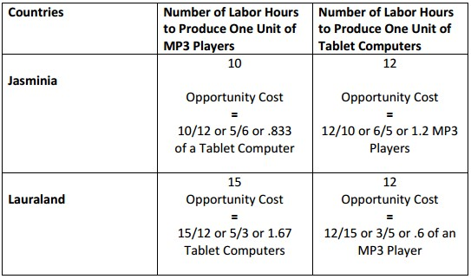

To illustrate comparative advantage using the OUTPUT method, let us look again at the example using Matthewtopia and Damianland. The problem presented is an OUTPUT problem because the numbers represent the number of units of each good produced given the same amount of resources. Use the number of units to find out how much of one good each country must give up to produce the other good. For output problems, we have to express opportunity cost as the ratio of “what we are giving up” divided by “what we are producing”. The ratios in each box below represent the opportunity cost of producing the other good. When reading this information, say it the following way:
“When Matthewtopia produces MP3 players, it gives up .5 of a tablet computer. When Damianland produces MP3 players, it gives up .33 of a tablet computer.”
Since Damianland gives up less to produce MP3 players, it has the comparative advantage in production. It should specialize in this product.
When Matthewtopia produces Tablet Computers, it gives up 2 MP3 players. When Damianland produces Tablet Computer, it gives up 3 MP3 players. Since Matthewtopia gives up less to produce

Tablet Computers, it has the comparative advantage in production. It should specialize in this product. Damianland should trade its MP3 players to Matthewtopia in exchange for Matthewtopia’s tablet computers. By specializing and trading, both countries will be able to consume more goods than they could when they produced both goods.
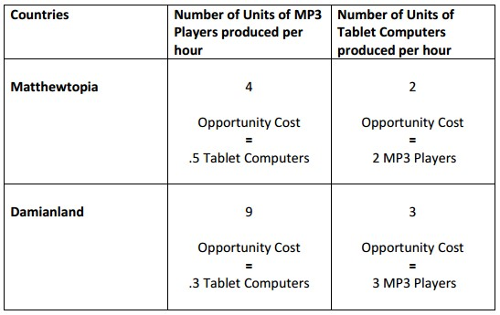

- Explain that most trade takes place because of comparative advantage in the production of a good or service.

Based on the examples used in SSEIN1a, the country with the lowest opportunity cost for producing a good or service should specialize in that good and then trade with another country for the other good. By producing those goods for which it has the lowest opportunity cost, countries can consume beyond the production possibilities of their own country. Specialization allows countries to allocate resources to their best possible use and creates greater economic efficiency.

- Define balance of trade, trade surplus, and trade deficit.
A country’s balance of trade refers to the value of its exports minus the value of its imports for measurable during a specific time. Remember, this is the calculation used to determine the value of the Net Exports component of GDP. If the value of a country’s exports exceeds the value of its imports, the country enjoys a trade surplus. If the value of a country’s exports fall short of the value of its imports, the country has a trade deficit.

LVL 2 Consider the following questions
12) How do you express the opportunity cost when solving an input problem of production?
13) What do the ratios represent when solving the comparative advantage?
14) How would you verbalize a ratio for comparative advantage?
15) How is the output method different from the input method when calculating opportunity costs?
16) What should countries do when they have the comparative advantage for producing a good?
17) Why does specialization help grow economies?

LVL 3 Do the following
18) Create a scenario with two imaginary countries and two goods that they produce and fill in the blank table below
Countries | # of units of _____________________ | # of units of ____________________

19) Explain which country has a comparative advantage in which product and how you got to that conclusion.

20) Is there a potential scenario where these countries would NOT trade? Explain and give an example

