2.1 Legislative Branch
SSCG8: Demonstrate knowledge of the legislative branch of government.
SSCG8a: Cite the formal qualifications for representatives and senators listed in the Constitution.
There are 435 members in the House of Representatives. There are three formal qualifications outlined in the United States’ Constitution, which says that a member of the House: 1) must be at least 25 years of age, 2) must have been a United States citizen for at least seven years, and 3) must be an inhabitant of the State from which he or she is elected.
There are 100 members in the Senate. There are two members for each of the fifty states. A senator must meet a higher level of qualifications, as outlined in the Constitution: 1) a senator must be at least 30 years of age, 2) must have been a citizen of the United States for at least nine years, and 3) must be an inhabitant of the State from which he or she is elected.

SSCG8b: Describe the election process for representatives and senators and how the 17th amendment impacted the election of senators.

Congressional elections are held on the same day in every state. For the House of Representatives, elections are held on the Tuesday following the first Monday in November of each even-numbered year. The congressional elections that are held in nonpresidential election years are referred to as off-year elections. ALL House of Representative members must run for election or re-election every two years.
The senate is referred to as a continuous body, which means that all of the seats are never up for election at the same time. Only one-third of the senators run for election every two years. Since a senator has a six-year term, only 33 to 34 senators run for election or re-election every two years.
Originally, senators were elected by the state legislatures; they were elected in this manner for the first 125 years following the passing of the U.S. Constitution. The 17th amendment was passed in 1913. The ratification of the 17th amendment placed the election of senators in the hands of the American citizens.
After 1913, both senators and representatives were elected by the people.

SSCG8c: Compare the terms of office for each chamber of Congress and explain the Founder’s intent.

The current size of the House of Representatives is 435 members. This number is not set in the Constitution, rather Congress decides on the number of members in the House. The Constitution does provide that the seats in the House of Representatives shall be apportioned, or distributed, among the states based on their populations. Each state is guaranteed at least one House member. The members are elected by registered voters in the district in which they represent. They have the advantage of having a smaller constituency, which includes the people and interests each House member represents. This provides an opportunity for representatives to be more involved and aware of issues that are important to the voters in their particular district.
The seats in the House may be reapportioned, or redistributed, based on the results of the census, which is conducted every ten years after the Census (the count of all people in the U.S.) is completed. Some states may gain a representative(s), while some may lose; the number of the membership remains at 435. All of the 435 members in the House have a two-year term, and there are no term limits. However, there is often conflict over reapportionment. Partisan state legislatures are in charge of re-drawing district lines and these lines often a drawn in ways that seem unfair and give a political advantage to one group over another. This purposeful redrawing of district lines to give a political advantage is called Gerrymandering.

Document 1
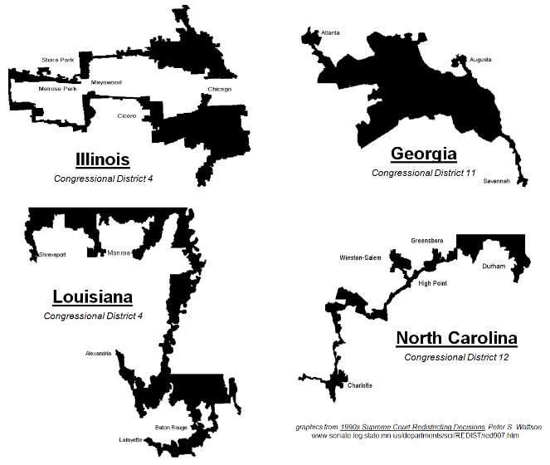

Document 2
If the US were a perfect Cartesian plane with states comprised of indistinguishable populations in areas neatly described by simple polygons, there wouldn't be any gerrymanders. But you can't start with a jurisdiction shaped like Maryland or Texas, populated by people with varied interests, living in neighborhoods ranging in population density from nearly twenty thousand people per square mile to, well, one person per square mile, you can't draw a district that looks like a checkerboard with residents who all have the same interest in things like farm support payments, subsidizing mass transit, limiting government control of firearm ownership, funding abortion clinics and naming things after Ronald Reagan.

The current size of the Senate is 100 members. Each state is represented by two senators. Senators are elected state-wide and represent all of the constituents in their state. Senators serve a six-year term, and as in the House, there are no term limits. This six-year terms gives senators a greater degree of job security. Senators are supposed to be more focused on the bigger picture of the needs and interests of their state as a whole, versus need and interests of individual districts within the state.
The intent of the Founders was to design a bicameral legislature, or a legislature with two houses. There are three reasons that the founders preferred the bicameral structure. First, historically, the Founders were familiar with the design of the British Parliament, which had two houses. This system of legislating was familiar to the founding fathers. Second, the bicameral design was a practical matter. There was a conflict between the Virginia Plan and the New Jersey Plan. Virginia wanted representation based on population, while New Jersey wanted equal representation for all states. The bicameral design of two houses solved this conflict. Each state is represented equally in the senate, and the House membership is based on population. Third, in theory this bicameral design would allow for a system of checks between both houses.

SSCG8d: Compare and contrast the powers of each chamber of Congress (e.g., power of the purse, 16th amendment, treaties, etc.
The House of Representatives has several powers assigned exclusively to it, including the power to initiate revenue bills, impeach federal officials, and elect the President in the event of an Electoral College tie. The power of the purse is another term for the initiation of revenue bills. ALL revenue bills must originate in the House. The majority of revenue is collected through taxation. A tax is a charge levied by the government on personal income, corporate income, or property. The 16th amendment to the Constitution gives Congress the power to levy income taxes without apportioning it among the states or basing it on the U.S. census.
The Senate has several powers assigned exclusively to it by the Constitution including the sole power to confirm Presidential appointments, ratify treaties, and try cases of the impeachment of federal officials.

