TOPIC 7 BUSINESS TYPES

LVL I: As you read, answer the questions that follow
- What are the four market structures in a mixed-market economy?
- What is Liability?
- What is the lifespan of a business?
- Why do corporations pay a double tax?
- Who has the most control over the price of their product, and why?
- What are the advantages of a sole proprietorship?
- What are the disadvantages of a partnership?
- What are the advantages of a corporation?

- Compare and contrast three forms of business organization—sole proprietorship, partnership, and corporation with regards to number of owners, liability, lifespan, decision making, and taxation.

Sole proprietorships are firms legally owned by only one person. Partnerships are firms legally owned by two or more people. Corporations are firms legally owned by stockholders who have purchased “shares” of the company in the hope that the value of their shares will increase over time and pay dividends. Dividends are money payments distributing some of a firm’s profit to shareholders on a quarterly basis. While sole proprietorship, partnerships, and corporations are the three main ways to organize a business in the U.S., students should understand that there are many variations of these forms in real life with complex rules. The following chart provides a comparison of the three basic types of business organization. Liability refers to responsibility for paying the debts of the business. Unlimited liability means that if a business is unable to meet its financial obligations, the owner(s) of the business are personally responsible to pay those debts. This means the owner(s) could be required to liquidate personal assets such as their home to pay the debts of the company. Limited liability is when responsibility for the debts of the business are restricted to the ownership stake (shares of stock) the business owner owns. The personal assets of the shareholder are not in jeopardy. Lifespan of the business refers to what happens to the business when an owner leaves or dies. Limited life means the business closing or reorganizing a business under the new owner(s) when the previous owner(s) leave the business. Unlimited life means the business passes to new owners through the sale of shares without ending the business. Decision making refers to the entity responsible for the day-to-day operating decisions of the business. The way a business is organized affects taxation on the profits of the business. Sole proprietorships and partnerships face a single tax on their business profits as income. The amount of income they earn from their business will determine the income tax rate charged. Corporations must also pay corporate income tax on profits. The profit income distributed to shareholders in the form dividends is also taxed. This is double taxation.

Type of  Business  Organization | How many owners are there? | What type of liability do owners have? | What is the lifespan of the business? | Who makes the operating decisions? | What type of taxation do owners have?
Sole Proprietorship | One | Unlimited | Limited | Owner | Single
Partnership | Two or more | Unlimited | Limited | Owners | Single
Corporation | Determined by who owns  shares of the  corporation’s stock | Limited | Unlimited | Board of  Directors elected by  shareholders; Professional  Managers and  Employees | Double

Although not expressly required by this element, you may want to categorize these characteristics of the types of business organization into advantages and disadvantages. The following chart accomplishes this task and includes some other key comparisons.
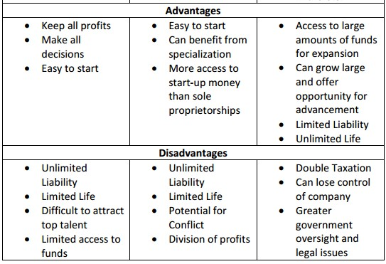

LVL II APPLICATION

For each situation below, identify whether you think this situation is best suited for a sole-proprietorship, partnership, or corporation and EXPLAIN ONE BENEFIT and ONE DRAWBACK they will face if they choose your suggestion (you may use the back).
1. Jim’s pressure-washing company is growing exceptionally fast and he will soon need to purchase several new machines and increase his advertising.
2. Marlee has just graduated Law School and is considering opening her own law practice.
3. Sophie runs a small bakery, but is not good with keeping up with the business end of things.
4. Phil is an expert painter and about is about to begin selling his paintings online.
5. Mira and Lesley are interested in starting a nail salon.

