**Topic 5 Price Controls**

**LVL I: As you read answer the questions that follow**

1. What is a government price floor?
2. What is a government price ceiling?
3. What is the result of a price floor?
4. What is the result of a price ceiling?
5. **Explain and illustrate on a graph how prices set too high (e.g., price floors) create surpluses, and prices set too low (e.g., price ceilings) create shortages.**

In some limited circumstances, governments or producers will choose to set a market price rather than allow the forces of supply and demand to determine the market price. A price set above equilibrium price is a **Price Floor.** A price set below equilibrium price is a **Price Ceiling.** Since these set prices are above or below equilibrium, the quantity supplied will not equal the quantity demanded in the market. Since price floors are above equilibrium, there will be a larger quantity supplied than there is a quantity demanded. When quantity supplied is greater than the quantity demanded, there is a surplus of the product in the market. Since price ceilings are below equilibrium, there will be a larger quantity demanded than there is a quantity supplied. When quantity supplied is less than the quantity demanded, there is a shortage of the product in the market. In the example below, the demand and supply schedule table shows that equilibrium price is $2.00. This price is the one at which the quantity demanded is equal to the quantity supplied. If price is legally set at $1.00, this is a price ceiling. Under this condition, the quantity demanded is greater than the quantity supplied and there is a 100-unit shortage in the market. If price is legally set at $3.00, this is a price floor. Under this condition, the quantity demanded is less than the quantity supplied and there is a 100-unit surplus in the market.

|  |  |  |  |  |  |  |  |  |  |  |  |  |  |  |  |  |  |
| --- | --- | --- | --- | --- | --- | --- | --- | --- | --- | --- | --- | --- | --- | --- | --- | --- | --- |
| |  |  |  |  | | --- | --- | --- | --- | | **Price** | **Quantity**  **Demanded** | **Quantity**  **Supplied** | **Condition in the Market** | | $1 | 200 | 100 | 100-unit  Shortage | | $2 | 150 | 150 | Equilibrium | | $3 | 100 | 200 | 100-unit Surplus | | 150    Demand    Quantity    Price    $1  $3    200    100    $2    Supply |

**LVL II Application**

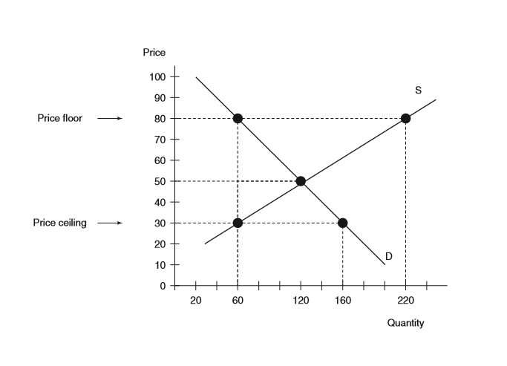

1. What is the market-clearing price in the graph below?
2. What quantity is demanded and what quantity is supplied at the market clearing price?
   1. Quantity demanded ________________
   2. Quantity supplied ________________
3. What quantity is demanded and what quantity is supplied if the government passes a law setting a maximum price of $30?
   1. Quantity demanded ________________
   2. Quantity supplied ________________
4. What quantity would be demanded and what quantity would be supplied if the government passed a law setting a minimum price of $80?
   1. Quantity demanded ________________
   2. Quantity supplied ________________