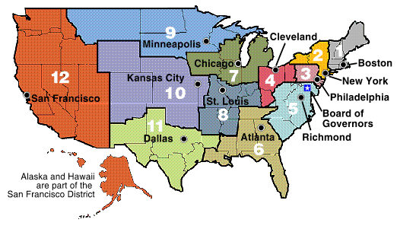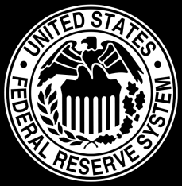**Monetary Policy**

**WHAT**: Federal Reserve’s (aka the Fed) use of their 4 `tools to influence (or change) the money supply

*How does this all work?*

The Fed has two ways they can change monetary policy. The can expand the money supply (put money into the economy) through their *Easy Money Policy* or they can contract the money supply (take money out of the economy) through their *Tight Money Policy*

*Why would they put money into the economy or take money out?*

They would put money into the economy if it is hurting – if we are in a contraction (slowdown, recession or depression). So you EXPAND the money supply to help ease a contraction in the economy.

They would take money out if the economy is growing too fast and inflation is becoming a problem. So you CONTRACT the money supply to help stabilize an expansion in the economy.

**WHAT ARE THE 4 TOOLS THEY USE?**

1. **Open Market Operations**

*What is Open Market Operations?*

It is the buying and selling of government bonds (aka government securities).

*Who do they buy from or sell to anyway?*

The Fed buys and sells bonds from banks, investment companies and other securities agencies. They do NOT buy or sell directly to the people.

* The Fed can *buy bonds* from banks which means *the Fed* gives banks *money* in exchange for the *bonds*. The Fed get the bonds and the bank gets money. There is now more money in the economy

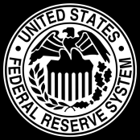

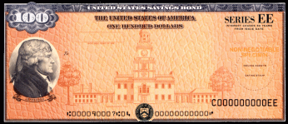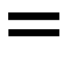

*MONEY*

BUY



* When the bank has *more* money, it can give out more loans to people.



* More loans = more spending by people!

OR

* The Fed can *sell bonds* to banks which means banks give the Fed money in exchange for bonds. The Fed gets the money and the bank gets the bonds. There is now less money in the economy.



*MONEY*

SELL



* When the bank has *less* money, it can’t give out as many loans to people .

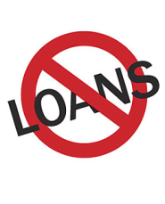



* Fewer loans = less spending by people!

**Remember!**

MORE

SPENDING

MORE

LOANS

MORE

MONEY

**Buying bonds =**

so

so

LESS

SPENDING

LESS

MONEY

LESS

LOANS

**Selling bonds =**

so

so

1. **Reserve Requirement**

*What is the Reserve Requirement?*

It is the amount of money all banks are required to keep in their vault at all times. (The amount they have to keep is a percentage of the amount of money that their customers deposit in the bank.)

* The Fed can *lower* the reserve requirementonbanks which means the banks have to hold *less* money in their vaults.

RESERVE

REQUIREMENT

*MONEY*

* This means banks can make *more* loans so there is *more* money in the economy!
* C:\Documents and Settings\YJR14313\Local Settings\Temporary Internet Files\Content.IE5\BMPCNWT6\MC900423171[1].wmfMore money = more spending!

OR

* The Fed can *raise* the reserve requirementonbanks which means the banks have to hold *more* money in their vaults.

*MONEY*

RESERVE

REQUIREMENT

C:\Documents and Settings\YJR14313\Local Settings\Temporary Internet Files\Content.IE5\VBEJ56BL\MC900423163[1].wmf

* This means banks make *fewer* loans, so there is *less* money in the economy



* Less money = less spending

1. **Discount Rate**

*What is the Discount Rate?*

It is the interest rate the Fed charges banks when they need to borrow money.

*Why would banks need to borrow money?*

If they loan out too much money and fall below their reserve requirement, they might borrow to get back up their required level.

* The Fed can *lower* the discount rateforbanks which means it is cheaper for the banks to borrow money. If it is cheaper for banks to borrow money, they are more willing to loan it to consumers.

DISCOUNT

RATE

*MONEY*

* C:\Documents and Settings\YJR14313\Local Settings\Temporary Internet Files\Content.IE5\BMPCNWT6\MC900423171[1].wmfThis means banks can make *more* loans so there is *more* money in the economy!
* More money = more spending!

OR

* The Fed can *raise* the discount rateonbanks which means it is *more expensive* for the banks to borrow money. If it is more expensive for banks to borrow money, they are *less willing* to loan it to consumers.

DISCOUNT

RATE

*MONEY*

C:\Documents and Settings\YJR14313\Local Settings\Temporary Internet Files\Content.IE5\VBEJ56BL\MC900423163[1].wmf

* This means banks make *fewer* loans, so there is *less* money in the economy
* Less money = less spending

1. **Interest on Required and Excess Reserves**

***What are interest on reserves?*** Federal Reserve will pay interest on required and excess reserves of financial institutions? (for the money that they keep IN the financial institution)

Banks will be loaning out less money---Less Money = Less Spending

* **The FED CAN increase the interest rate on reserves—banks will be incentivized to KEEP money in the bank and NOT loan it out (because they will be earning more interest on money they are keeping in the bank)**

This will be good when the fed wants to increase the interest rate on reserves

They will do this when they are concerned about inflation

Money supply will decrease and

* PRICE LEVEL WILL FALL
* REAL GDP WILL FALL
* UNEMPLOYMENT WILL RISE

OR

* **The FED CAN Decrease the interest rate on reserves-- banks will be incentivized to LOAN the money out and NOT KEEP it in the bank (because they will not be earning any more money to keep it in the bank)**

They will do with when they are concerned about contraction (recession)

Banks will be lending out more money----more money=more spending

Money supply would increase

* PRICE LEVEL WILL RISE
* REAL GDP WILL RISE
* UNEMPLOYMENT WILL DECREASE