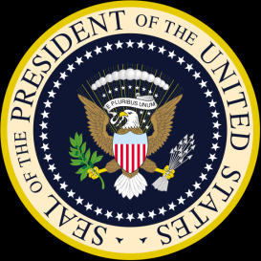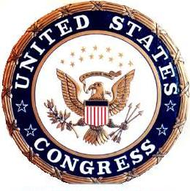**Fiscal Policy**

**WHAT**: Federal government’s taxing and spending decisions to influence the health of the economy

**HOW DO TAXES WORK**:

Taxes can increase or decrease

* If taxes *decrease*, we get to keep *more* of our money.



When we have more money, we spend more!

C:\Documents and Settings\YJR14313\Local Settings\Temporary Internet Files\Content.IE5\VBEJ56BL\MC910217510[1].wmf

This is called

* If taxes *increase*, we keep *less* of our money.



When we have less money, we spend less.

This is called

**HOW DOES GOVERNMENT SPENDING WORK:**

* Government’s get their money from us in the form of taxes. HOWEVER, if they change their spending, it does NOT mean TAXES have changed!
* Government spending can increase or decrease.
* When the government spends money, they are buying goods and services or resources from us. This means that when they spend, money comes to us.
* If government spending *decreases*, they are buying *fewer* goods or resources from us, so **we** get *less* money.



When we have less money, we spend less.

This is called

* If government spending in*creases*, they are buying *more* goods or resources from us, so **we** get *more* money.



When we have more money, we spend more!

C:\Documents and Settings\YJR14313\Local Settings\Temporary Internet Files\Content.IE5\VBEJ56BL\MC910217510[1].wmf

This is called