Circular Flow

LVL I Answer the following questions as you read
- What are the two main sectors of the economy?
- What do households need businesses for?
- What do businesses need households for?
- What does household income go toward?
- What does business revenue go toward?
- What does the Circular Flow Model (CFM) demonstrate?
- What is the resource, or factor, market?
- What is the product market?

- Illustrate a circular flow diagram that includes the product market, the resource (factor) market, households, and firms.

Within an economy, there are sectors that have specific roles to play in economic activity. These sectors depend upon each other to play each role effectively. The two main sectors are households and businesses (firms). Households need businesses to purchase resources from them in exchange for income and to make goods and services for the households to purchases. Businesses need households to sell their resources to firms so they will have the inputs required to make goods and services. Business need households to purchase the goods and service they produce so the business can take in revenue (price times the quantity sold) and return a profit to the entrepreneur(s) who own the business. Businesses use money to pay households for their resources and households use the money they earned as income to purchase goods and services.

The Circular Flow Diagram is a model economists use to show the characteristics of and relationships that exist between households and businesses in the economy.
Households, in the Resource Market (factor market), are the owners of the productive resources (factors of production) in the circular flow model. They sell their land, labor, capital, and entrepreneurship to businesses (firms) in the Resources Market in exchange for income payments.
Households, in the Product Market, are consumers of goods and services in the circular flow model. They buy goods and services from businesses. They spend the income they earned in the Resource Market to buy these goods and services. Consumer “expenditures” is a fancy word for spending.
Businesses (firms) in the Resource Market are the consumers of the productive resources (factors of production) in the circular flow model. They purchase the use of land, labor, capital, and entrepreneurship from households in the Resource Market (Factor Market) using the revenue they earned in the product market.
Businesses (firms) in the Product Market are producers of goods and services in the circular flow model.
They sell goods and services to households. They earn revenue in exchange for their goods and services.
- Explain the real flow of goods, services, resources, and money between and among households and firms.

In the circular flow diagram below, businesses and households are the sectors of the economy located across from each other on the diagram. The resource and product markets are also located opposite from each other on the diagram. In between the sectors and markets, there are flows of goods and services, resources, and money payments.
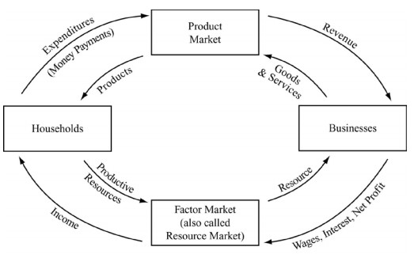
Businesses need productive resources in order to produce goods and services. They go to the resource market to buy productive resources from households. Wages, interest, rent, and profit flow from businesses to the resource market, becoming the flow of income from the resource market to the households. Land, labor, capital, and entrepreneurship flow from households through the resource market to the businesses.
On the other side of the diagram, households use their income for spending or “expenditures” in the product market. Spending flows from households to the product market becoming the revenue that flows from the product market to the businesses. Goods and services flow in the opposite direction from businesses to households through the product market.
It is important to note that the arrows on the inside of the diagram all flow in the same direction, making a circle. This is true for the arrows on the outside too which flow in the opposite direction from those on the inside. On the example diagram shown, notice that the inside circle flows are goods, services, or resources and the outside circle flows are all money payments.

LVL II Consider the following questions
- What do households represent in the circular flow model?
- What do firms represent in the circular flow model?
- Explain the difference between the factor market and the product market
- Explain why the households and firms are inter-dependent and how money plays an extremely import role in the economy.
LVL III Do the Following
- Draw and label the CFM with the business on the left.
- After looking at the CFM, why does each sector depend on one another?
- Describe how a transaction would move through the CFM.

